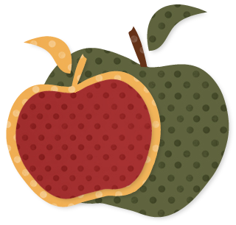
Back to School Menu Planner
1. Old-Fashioned Spaghetti & Meatballs (Make double batch of meatballs for later in the month)
2. Sloppy Joes & Seasoned Baked Potato Wedges
3. Caesar Chicken Pasta Salad With Homemade Pitas
4. Pita Pizzas (made from leftover pitas) & Salad
5. Parmesan Chicken Drumsticks, Steamed Broccoli, & Rice
6. Oatmeal Waffles with homemade syrup & orange juice
7. Leftovers Night
8. Chicken Broccoli Lo Mein with Rice
9. Herb Baked Tilapia, Chicken-Flavored Rice, & Microwave Corn in Butter Sauce
10. Meatball Subs on Homemade Rolls (meatballs from freezer)
11. Jerk Chicken, Mashed Potatoes, & Baby Peas
12. Homemade Pizza Night
13. Slow Cooker Lemon Chicken, Rice, & Steamed Broccoli
14. Leftovers Night
15. French Toast with homemade syrup & orange juice
16. Italian Pork Chops over Spaghetti
17. Chicken BBQ with Pretzels & Carrot Sticks
18. Salmon Pockets, Rice, & Baby Peas
19. Chicken Pasta Milano with Salad & Bread
20. Homemade Pizza Night
21. Leftovers Night
22. Yeast Waffles with homemade syrup & orange juice
23. Chicken Tacos with Tortilla Chips
24. Sarah's Tilapia, Rice, & Corn
25. "Roasted" Chicken, Mashed Potatoes, & Baby Peas (save & shred leftover chicken)
26. Chicken Salad Sandwiches (from leftover chicken), Pretzels & Carrot Sticks
27. Bread Machine Calzones With Dipping Sauce
28. Leftovers

Snacks: Banana Bread, Chewy Granola Bars, Cinnamon Muffins, Air Popped Popcorn, Rice Krispie Treats, Oatmeal & Chocolate Chip Muffins

